

SERVICE NOTE FOR JOURNALISTS - the complete speech by the new president of Italian Exhibition Group, Maurizio Ermeti, is in attachment

press release

TTG TRAVEL EXPERIENCE, 60th EDITION INAUGURATED

- Daniela Santanchè, Minister of Tourism: «TTG, Italy's most important tourism show. First-half-year figures state +1.4% compared to the magical year 2019»

- Maurizio Ermeti, newly-appointed president of IEG: «Tourism, a perfect sector for our country that redistributes wealth to small and medium-sized enterprises»

- Until Friday at Rimini Expo Centre, 2,700 exhibiting brands and one thousand foreign buyers for the travel and hospitality supply chains and the new InOut contract community

ttgexpo.it | inoutexpo.it

Rimini, 11th October 2023 – Sixty candles for Italian Exhibition Group’s TTG Travel Experience, the «most important tourism trade show in Italy», in the words of Minister Daniela Santanchè, who took part today in the inaugural ceremony of TTG and InOut, dedicated to the contract sector. Tourism has restarted and showed encouraging signs for the first six months of the year with +1.4% compared to the same period in 2019, acknowledged by all as the industry’s magic year. Tourism, however, wants to take on a new life in view of new habits and the new needs of travellers and is trying to reshape its objectives under the banner of utopia, as indicated by the claim of the edition underway at Rimini Expo Centre until Friday. «It is a perfect sector for our country because it distributes wealth along the entire value chain of small and medium sized enterprises within the territories,» as IEG's new president, Maurizio Ermeti, underlined in his greeting.

At the exhibition, 2,700 exhibiting brands, one thousand foreign buyers, 58% from Europe and 42% from the rest of the world, and over 200 events in three days. IEG shows the market the very best of the Italian tourism product with all 20 regions and more than 60 foreign destinations, confirming the show as the reference event for both incoming and outgoing Italians. Spotlights on the foreign marketplace for the Mediterranean area with TTG Med and a focus on the luxury segment, thanks to encounters with a selection of foreign buyers specialised in high-end targets and looking for Italian excellence.

At the opening ceremony, after institutional greetings from Italian Exhibition Group’s newly-appointed president, Maurizio Ermeti, the mayor of Rimini, Jamil Sadegholvaad, and vice-president of the Senate, Gian Marco Centinaio, it was time for the round table with Andrea Corsini, Emilia-Romagna’s Regional Councillor for Tourism, Mobility and Transport, Infrastructures and Trade, Bernabò Bocca, President of Federalberghi, Ivana Jelinic, President of ENIT, Luigi Cabrini, President of the Global Sustainable Tourism Council and, of course, Daniela Santanchè, Minister for Tourism, all on stage in the Expo Centre’s Main Arena.

Maurizio Ermeti: «President Cagnoni has left us a great legacy and I do not hide my emotion in interpreting, as of today, his historic role,» began the new president of IEG, remembering his predecessor, who recently passed away. «It is also true that, for many years on the Board of Directors, he and I experienced the growth of this company together, starting with the construction of this beautiful Expo Centre, then the building of our Palazzo dei Congressi conference centre, the merger with Vicenza and the company’s listing on the stock exchange to become an increasingly important player in the Italian and international exhibition sector. We now have many new projects underway that aim to further improve and expand our premises and our business. But that’s not all. We intend to accompany and support the development of all the economic sectors that we preside over with our trade shows. One of these worlds is tourism, the protagonist of TTG and InOut, which we are inaugurating today. Tourism is a fundamental sector for the Italian economy, an industry that employs many people because it is based on human relations, a fair industry because it redistributes its income over a very long value chain populated by a huge number of small and medium-sized companies.»

Daniela Santanché: «Today allows us to take stock. Many results have been achieved in this first year of government: we have worked on important objectives, formulating answers that the sector had been asking for some time. We are changing our approach to stakeholders, identifying sharing and comparison as the cornerstones on which to focus our work, making decisions after dialogue with the sector's operators. Our ambition is to make tourism the leading contributor to national wealth: a goal that is within our reach, given that today the value of the sector, directly or indirectly, is already worth 13% of GDP; a figure that makes us look to the future with confidence and optimism and to the achievement of this result, which will only be possible when we succeed in releasing the power of tourism, freeing it from a marginal vision and turning it into a real industry. I pledge my commitment to this as well as that of the ministry that I have the honour of leading and of the executive, which, from the outset, has focused precisely on this sector. I would like to take the opportunity today to address all the operators in the sector who, with commitment, passion and self-sacrifice, every day are the true advocates of change: I give them my thanks and the promise that I will always be at their side.»

Gian Marco Centinaio: «Coming to TTG is always a pleasure, I meet colleagues and friends. To beach establishment entrepreneurs I say: we have done what we said we would do. The beaches have been acknowledged and what we have always told Europe has been seen and confirmed. Europe said that the resource is poor and that there are too many bathing establishments, but we have shown that this is not the case. And the trade associations are saying the same: only 33 per cent of the coastline is occupied. We will say this in Brussels.»

Bernabò Bocca: «We are satisfied with the 2023 season, even though the summer was a two-speed affair. Our domestic tourism experienced a downturn while foreign tourism, especially American, restarted very well. The theme of high hotel prices must be debunked: Federalberghi conducted a study on this and hotels represent 27% of a tourist's expenditure in Italy.»

Ivana Jelinic: «In every season, Italy is able to offer quality tourism for all tastes. SInce the pandemic, we have changed, as have everyone's needs. There is a great desire to travel and people are trying to do it in every possible way. Our “Venus” campaign abroad was and is highly appreciated, we will soon be sharing data on the visibility it generated.»

Jamil Sadegholvaad: «Never before has a real and concrete debate on the future of Italian and international tourism been so necessary. And never before, as in this year, has the best venue to hold it been TTG, IEG’s halls and the city of Rimini, one of the few seaside resorts capable of accumulating growth results in 2023 compared to 2022 and now, due to its historical and artistic heritage, officially nominated as Italian Capital of Culture for 2026.»

Andrea Corsini: «Investing in tourism means supporting the economy and proper employment in our country. The economic situation is difficult, there is a need to innovate by exploiting new technologies and big data to make our tourism offer increasingly capable of keeping up with the changing needs of tourists, who are now demanding ecological experiences with low environmental impact. For these reasons, Rimini’s TTG is an extraordinarily important moment of encounter and international debate where we are the key players.»

Luigi Cabrini: «We must overcome the conception of sustainability as an additional cost. I see it as neither an option nor a cost. It should be seen as an investment for two reasons. A company that decides to move towards sustainability will reduce costs within three years. And the market is moving towards a demand for sustainable products and experiences. Aware of the reduction in biodiversity, we feel that we must participate in this fight which translates into better quality tourism.»

ABOUT: TTG TRAVEL EXPERIENCE
Event: international trade show; organiser: Italian Exhibition Group SpA; frequency: annual; edition: 60th; entry: trade only; website: www.ttgexpo.it - #ttgexpo

ABOUT: INOUT, THE CONTRACT COMMUNITY.
Event: international trade show; organiser: Italian Exhibition Group SpA; frequency: annual; edition: 1st edition of INOUT which unites SIA, SUN, SUPERFACES, GREENSCAPE; entry: trade only; website: www.inoutexpo.it #inoutexpo

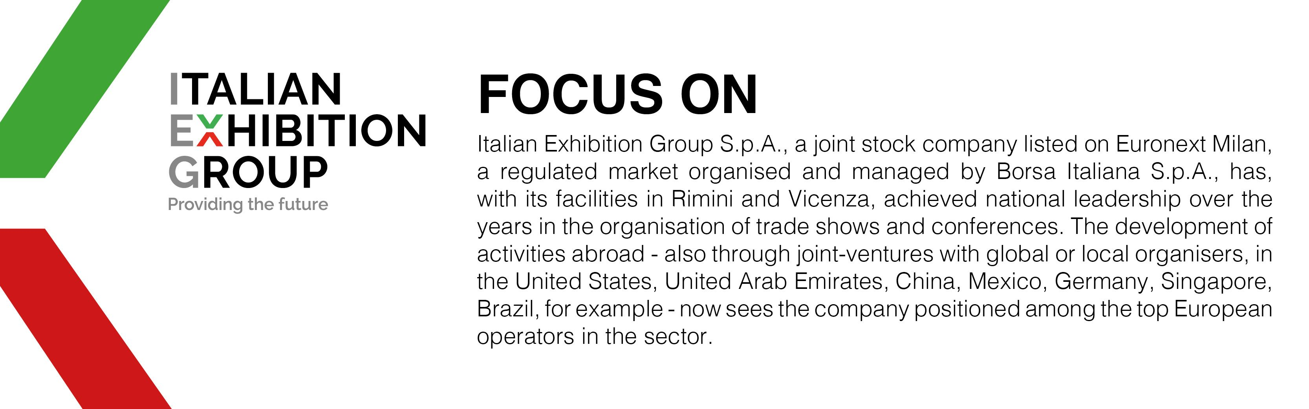

PRESS CONTACT ITALIAN EXHIBITION GROUP
Head of media relation & corporate communication: Elisabetta Vitali; press office manager: Marco Forcellini;
international press office coordinator: Silvia Giorgi; media@iegexpo.it

MEDIA AGENCY TTG Travel Experience 2023: MY PR Lab
Filippo Nani, +39 0444.512550, filippo.nani@myprlab.it; Francesca Magnanini, +39 338 6910347, francesca.magnanini@myprlab.it; Enrico Bellinelli, +39 392 748 0967, enrico.bellinelli@myprlab.it

This press release contains forecast elements and estimates that reflect the management’s current opinions (“forward-looking statements”), particularly regarding future management performance, realization of investments, cash flow trends and the evolution of the financial structure. For their very nature, forward-looking statements have a component of risk and uncertainty, as they depend on the occurrence of future events. The effective results may differ (even significantly) from those announced, due to numerous factors, including, only by way of example: food service market and tourist flow trends in Italy, gold and jewellery market trends, green economy market trends; the evolution of raw material prices; general macroeconomic conditions; geopolitical factors and evolutions in the legislative framework. Moreover, the information contained in this release does not claim to be complete, and has not been verified by independent third parties. Forecasts, estimates and objectives contained herein are based on the information available to the Company as at the date of this release.

